# Lab 3: Automating Code Deployments Using AWS CodePipeline

In this lab, we will learn how to automate deployments from AWS CodeDeploy by creating a 2-stage pipeline with AWS CodePipeline. You will deploy a Windows Service application to an Amazon EC2 Fleet running Windows Server OS.

Lab given objectives:

1. Use AWS Cloud9 to prepare your code and upload it to an Amazon S3 bucket.
2. Create a pipeline that automatically deploys your code from the S3 bucket to your servers using AWS CodePipeline and AWS CodeDeploy.
3. Check the deployment settings and automatically deploy your code with AWS CodeDeploy.

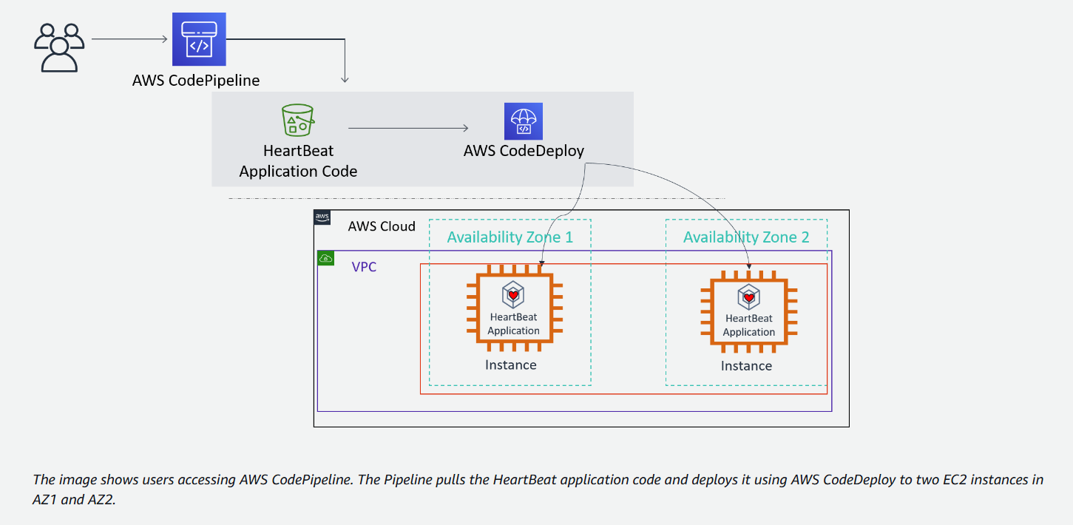

Objective 1: Review AWS CodeDeploy application that is already configured

1.1 Open CodeDeploy and select HBP-App

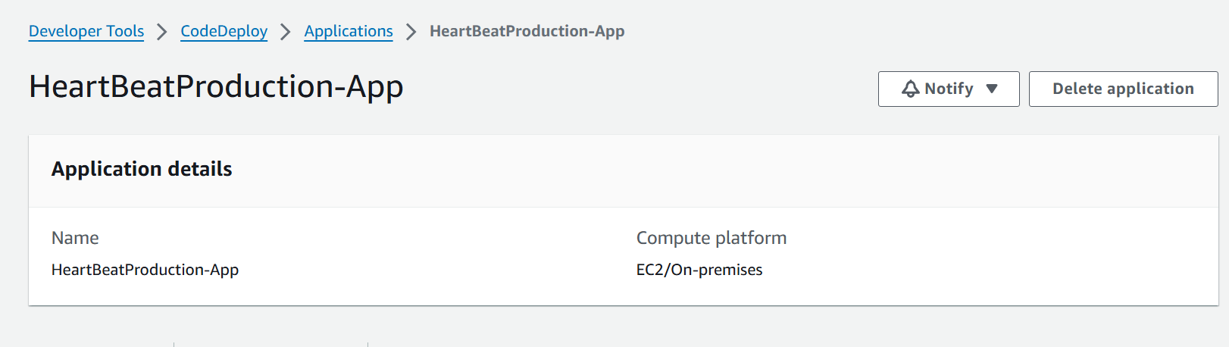

1.2 Open HBP-App in Deployment Groups

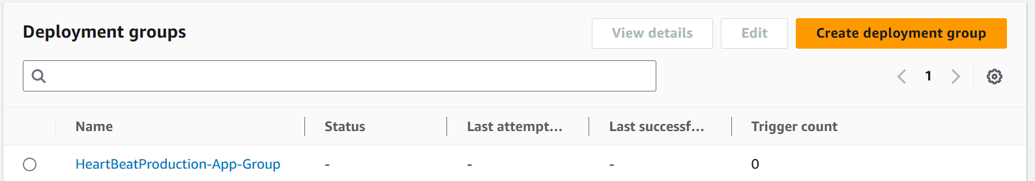

1.3 Verify these details

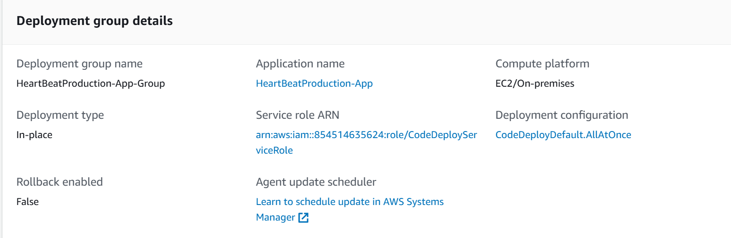

Reviewed the CodeDeploy application

Objective 2 - Preparing the application code for deployment

We store the HeartBeatProduction-App object in this Amazon S3 bucket. AWS CodePipeline deploys the object from this Amazon S3 bucket to the target EC2 fleet.

2.1 Open Cloud9, and execute these codes, to get the region in which Cloud9 instance is running

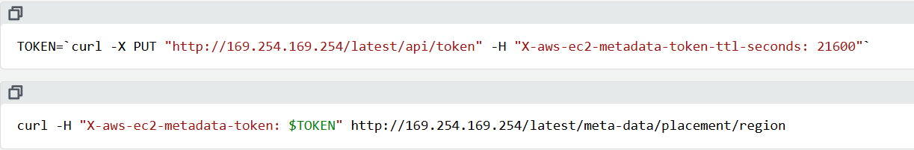

o/p- 

2.2 Run the following command to create a myRegion variable to be used in later commands



2.3 Run the following code



The command downloads a file named CodeDeployHeartbeatDemo.zip from an Amazon S3 bucket. The URL structure indicates that this file is hosted on an S3 bucket specific to a region, which is specified by the placeholder $myRegion.

Downloaded:-



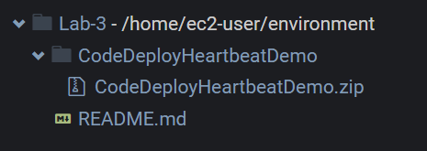

2.4 We need the Amazon S3 application source bucket name that was provided to complete this task and the next task.



2.5 Run the following command to create a variable with that bucket name:



2.6 Run the following command to copy the zipped file to your Amazon S3 bucket:



This copies the application files from the AWS Cloud9 IDE environment to the Amazon S3 Application Source bucket.

Objective 3-Creating an AWS CodePipeline

The purpose of this pipeline is to automate the deployment process from Amazon S3 source objects to AWS CodeDeploy deployment group targets.

3.1 Open CodePipeline to create a new pipeline



3.2 Select these settings

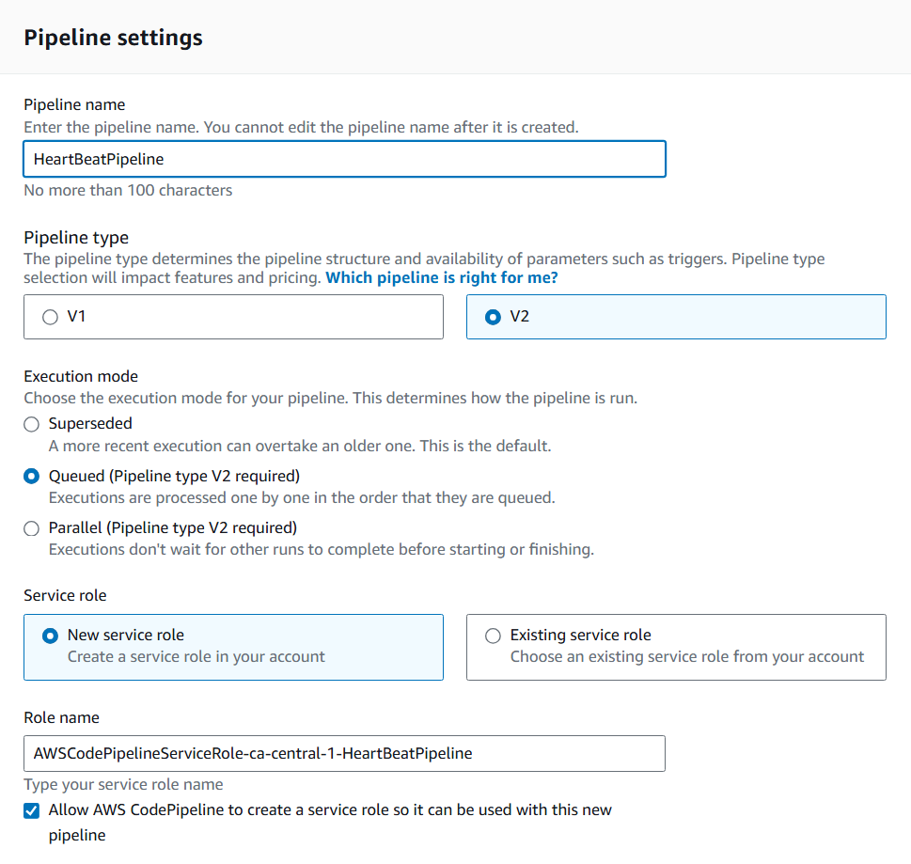

3.3 Select the source

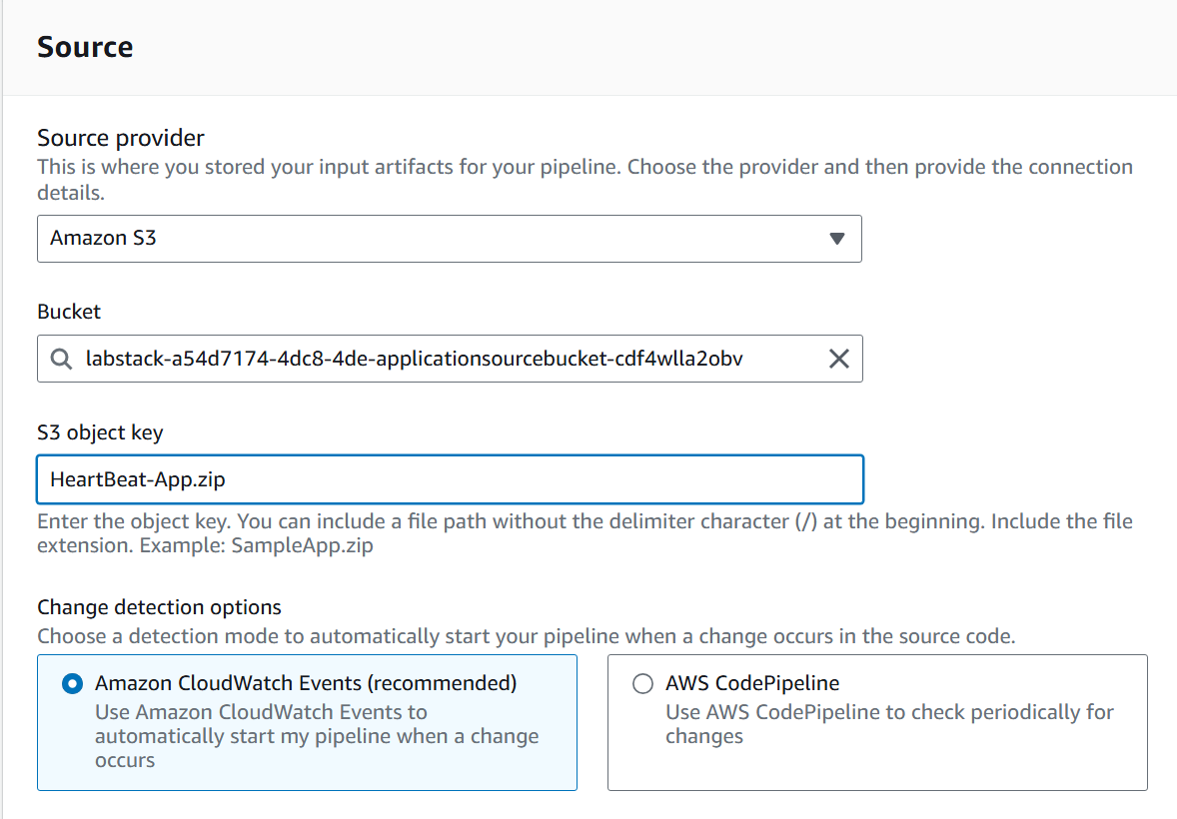

3.4 Configure the AWS CodePipeline where the code should be deployed to

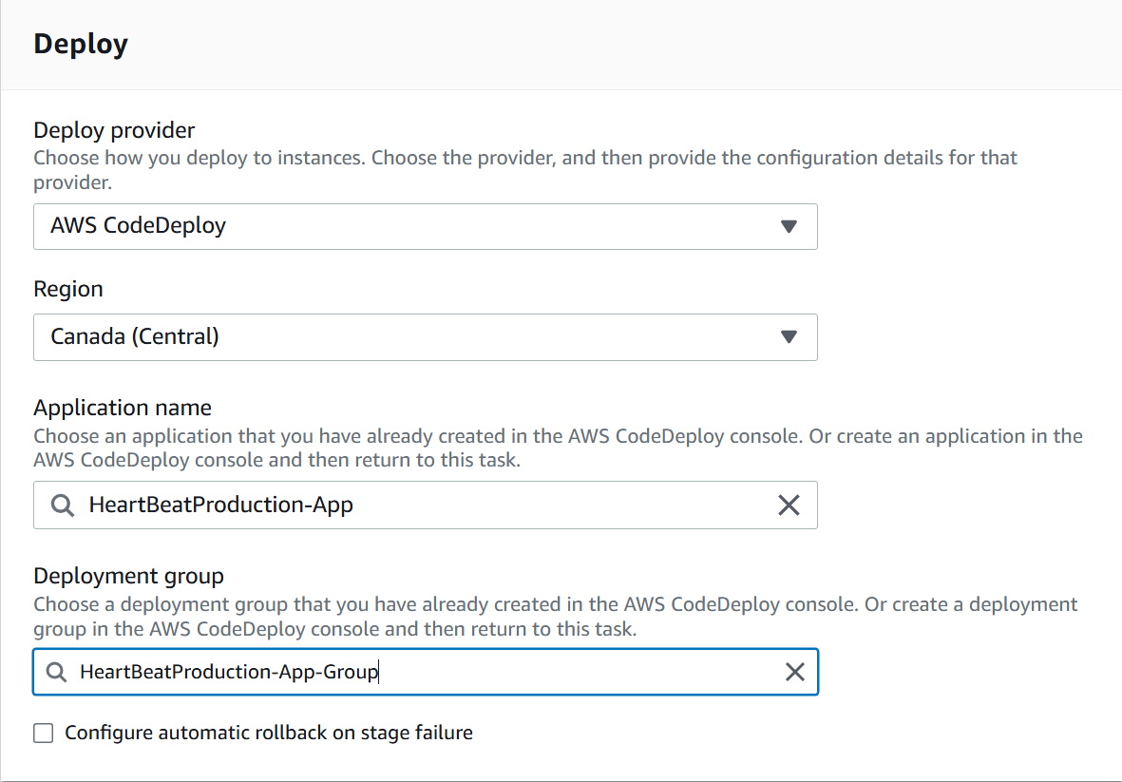

3.5 Review the settings

3.6 Once the pipeline is created, watch the automatic deployment from the Source stage to the Deploy stage until it completes.

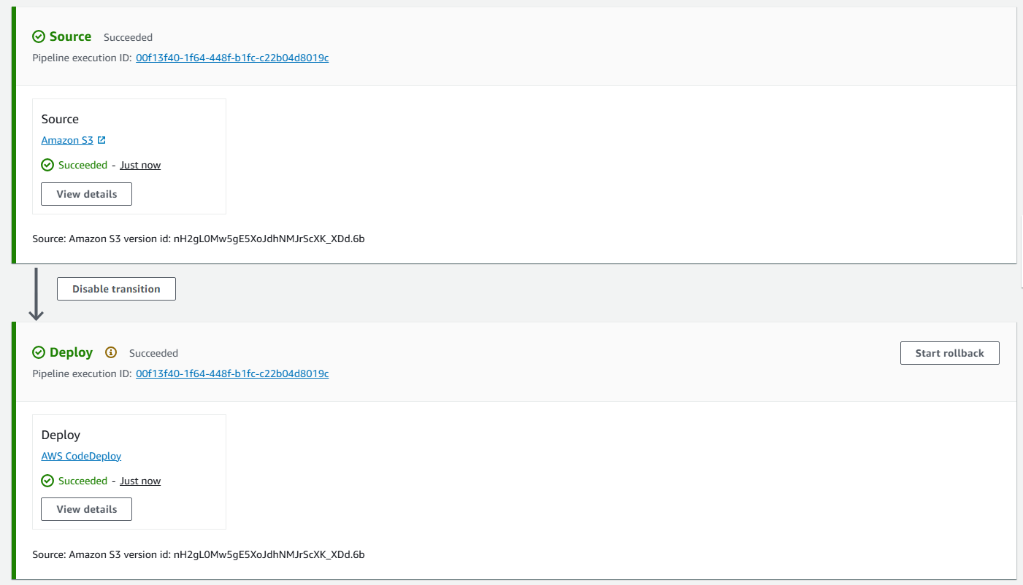

3.7 Force the pipeline to do a deployment by choosing Release change



3.8 The pipeline HeartBeatPipeline has been created.

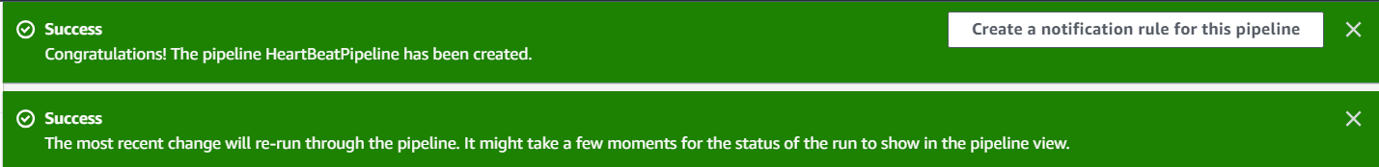

Objective 4- Verifying the CodePipeline deployment

4.1 Connect to HB-Instance in EC2 Insatances

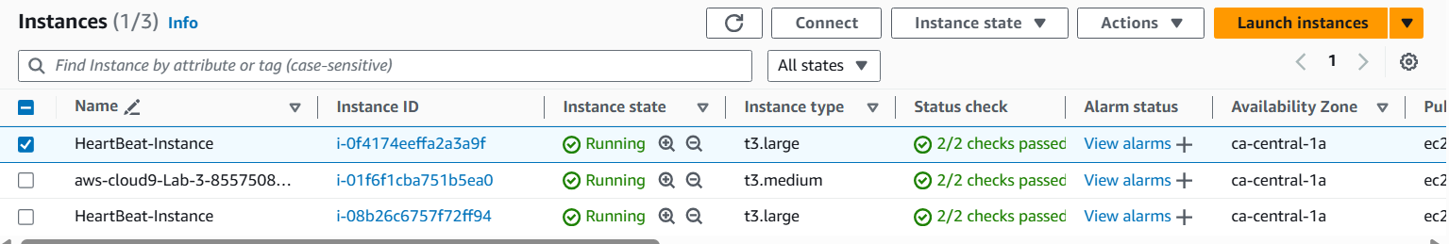

4.2 Use Windows PowerShell to verify that the HeartBeat service is running as expected after the deployment.

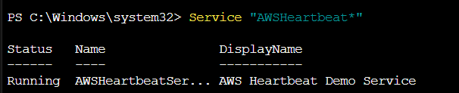

HBServices is running

***

***